**Quiz BF[1] – Using Software Cortland Watson**

Part I – Individual Quiz (Before Class)

Part II – Group Quiz (During Class)

1. What is a parallel dot graph (3 pts)?

Parallel dot graphs are graphs where observed values are put onto a graphic where the y value is the observation and the x values are the groups/categories.

1. What are four things to look for in a parallel dot graph (3 pts)?

Groups: how similar

Outliers: exist

Spread: spread within groups

Transforming: is a scale change worth considering?

1. What are the three tests for factors (2 pts)?

Do the observations have something in common independent of other groups?

Would averages be valuable?

If you change groups, does that change the data?

1. What is the definition of a p-value (2 pts)?

Probability of observing the value, given that the null hypothesis is true.

1. What are the reasons why the standard deviations should be equal (2 pts)?

When not equal, larger SDs tend to dominate the average.

Formal methods estimate one typical size for chance error.

1. What are the four features to look for in Residuals (2 pts)?

Outliers, gaps and lumps, asymmetry and skews, long or short tails

**End of Part I**

1. Were you in class on time (2 pts)?

YES

1. Do the following with the Fish Data:
   1. Construct a boxplots, dotplots, means plots and QQ-plots using the fish data and make some observations based on what you see in the plots (Use two software when doing this and show your graphs (3 pts).

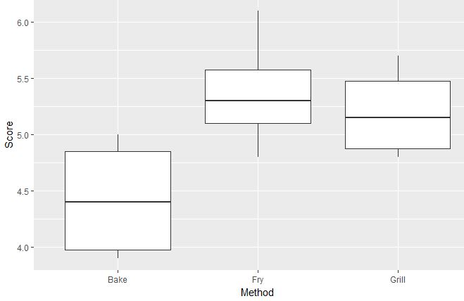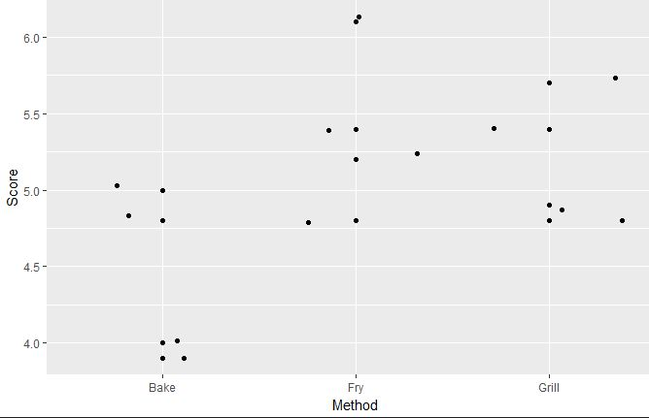

* 1. Check the requirements of equal variance and the residuals being normal. (3 pts)

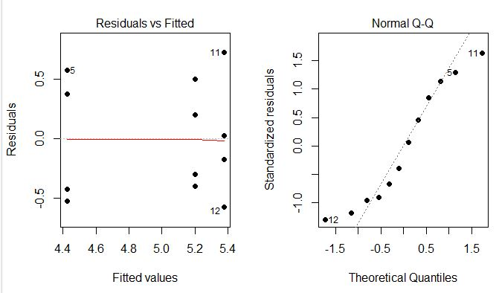

* 1. Get an ANOVA table from software and make conclusions (3 pts)

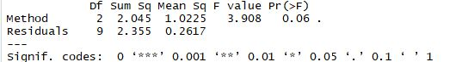

* 1. Whether the requirements are met or not, try any transformation and create an ANOVA table and draw conclusions from that table (3 pts).

The requirements for this test were not met. The qq plot shows that there is some abnormality in the data and that a transformation might be needed. I was unfortunately unable to figure out the transformation. The transformation is needed as the variance is not standard across the groups, and the normality plot curves out with tails at both ends of the plot suggesting that it is not normal data.